**Roll Number: 21BCE103**

**Course Code: 2CS504**

**Course Name: Software Engineering**

Github link: <https://github.com/kajallochab/Hostel-Management-System>

**Screen Shots:**

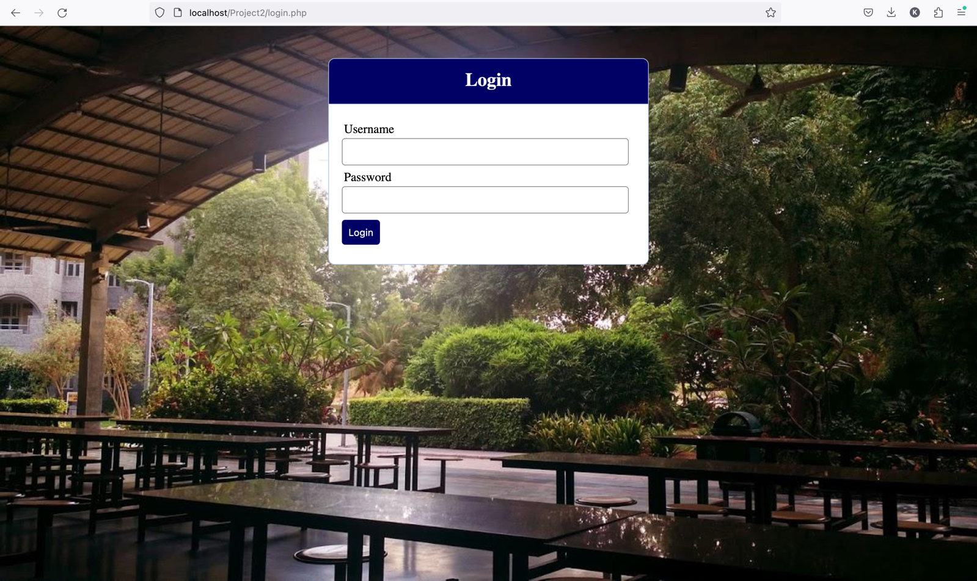

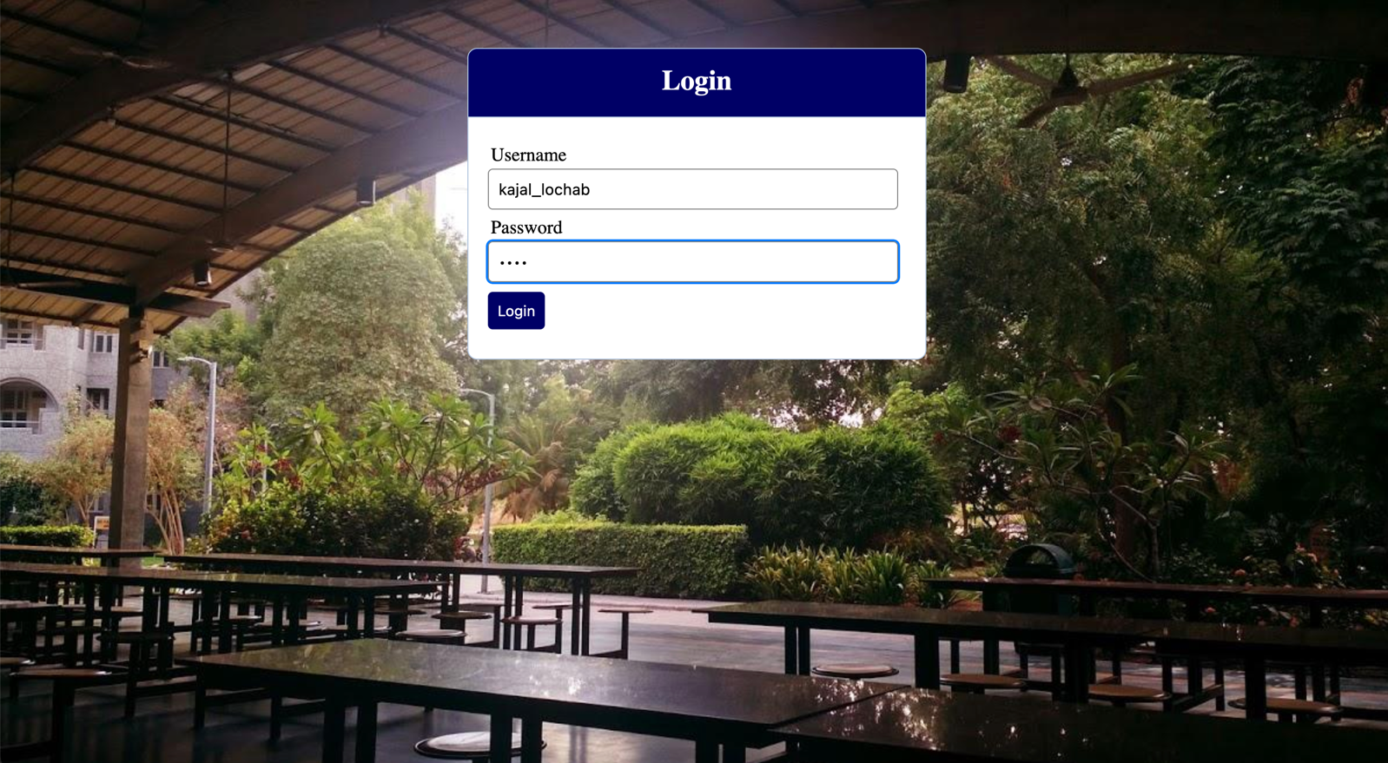

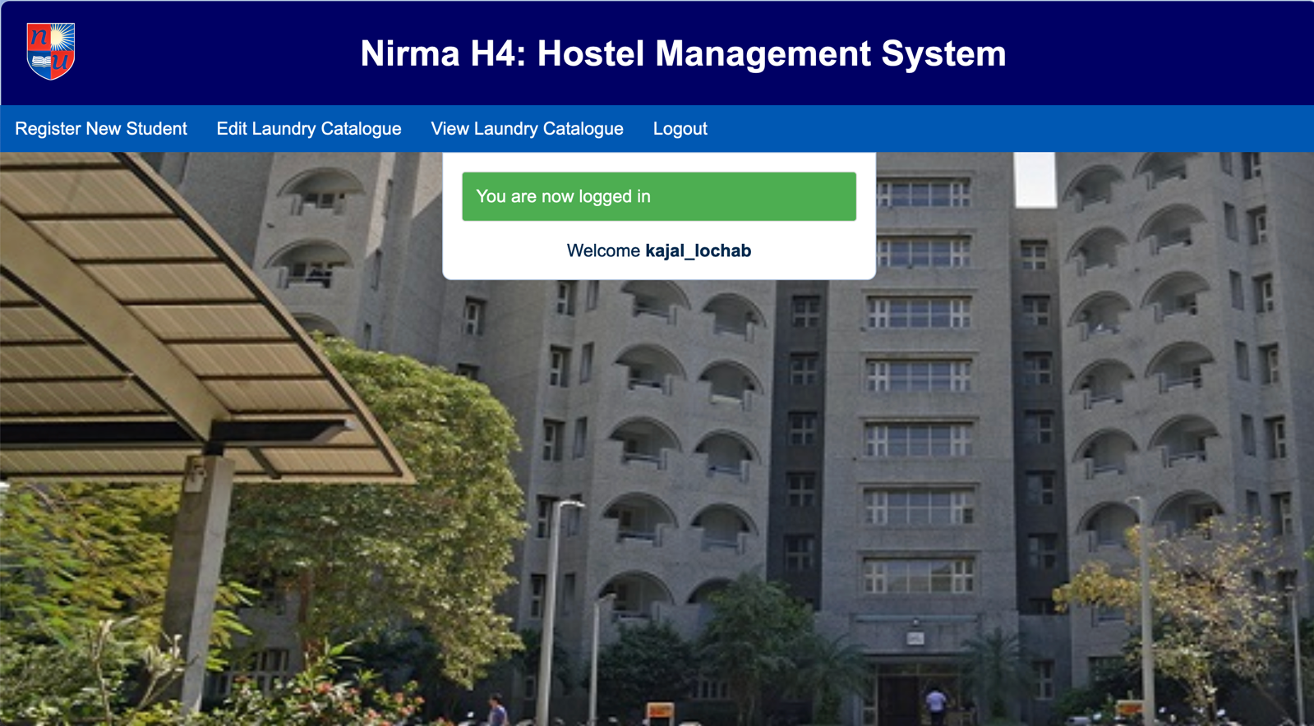

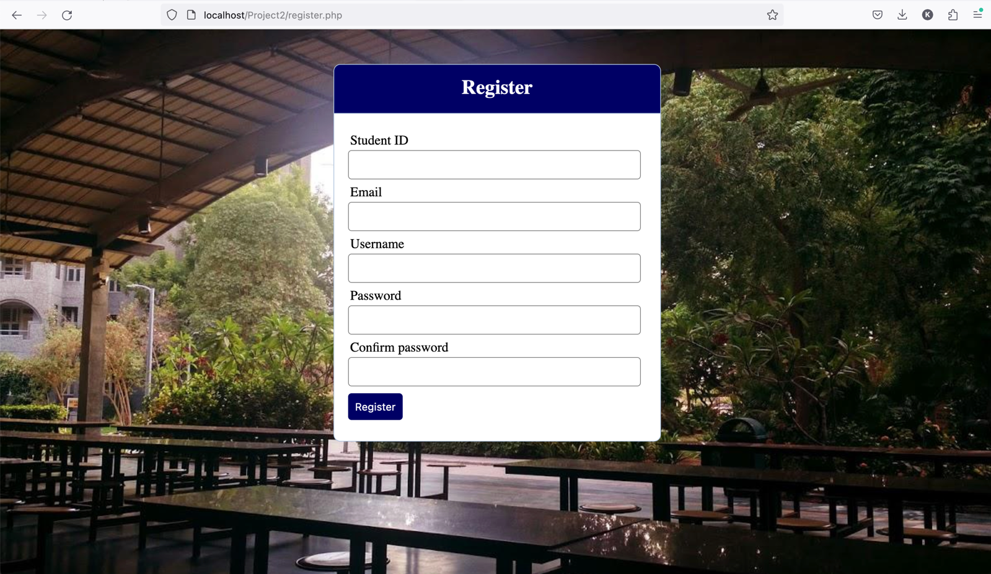

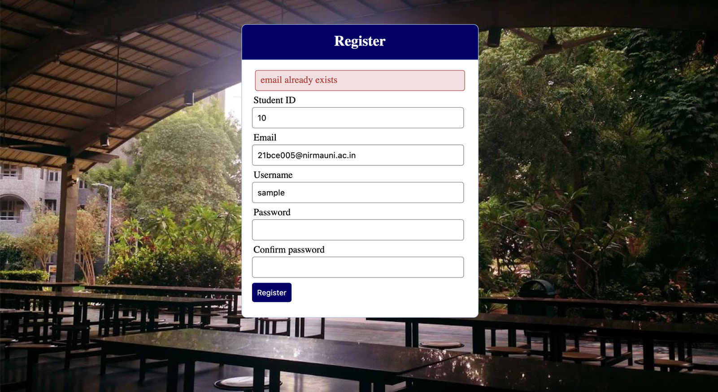

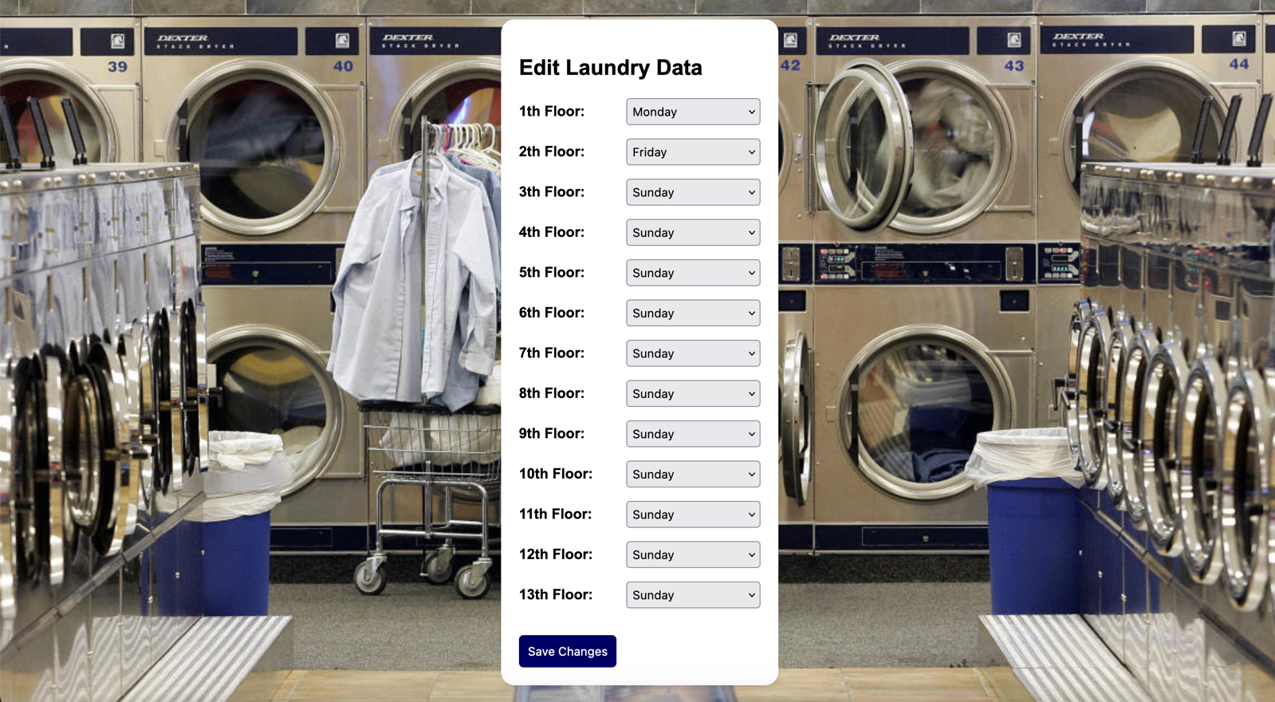

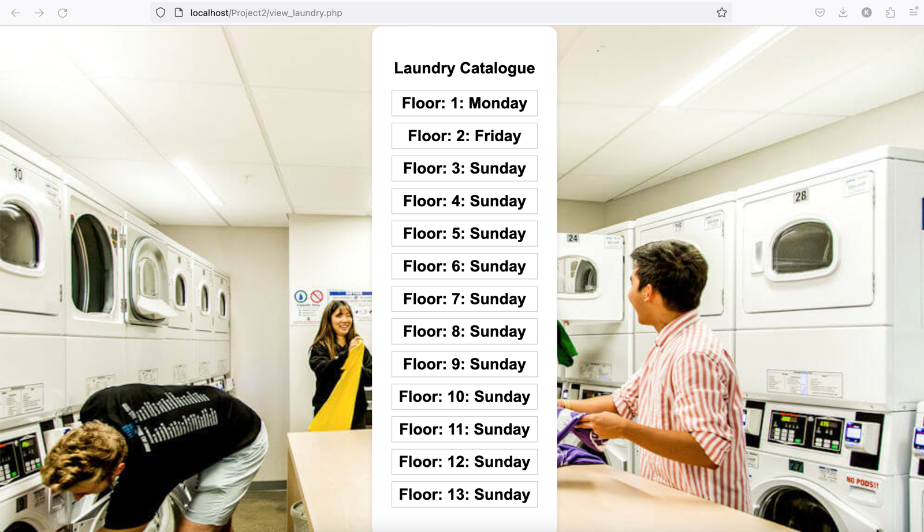

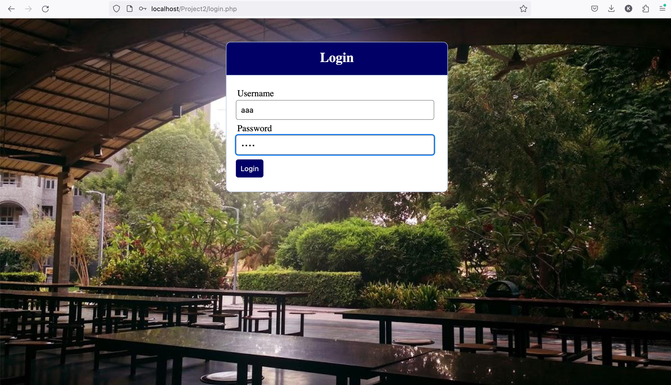

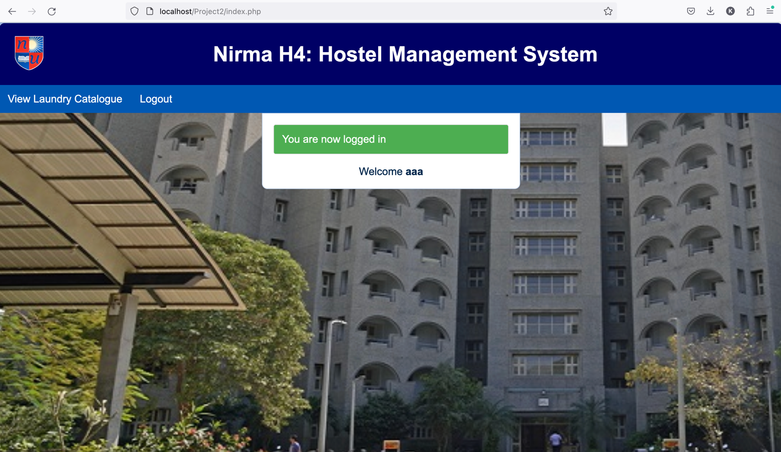

**Test strategy document:**

**1. Introduction**

This Test Strategy Document outlines the testing approach and objectives for the Hostel Management System, which is a crucial component of our college project. The purpose is to ensure the quality and reliability of the software application. This document serves as a guide for the QA team and stakeholders involved in the testing process.

**2. Scope**

**2.1 Review and Approval**

* **Reviewers:** The college project team and the advisor will review the document.
* **Approvers:** Final approval will be obtained from the project advisor and project team.

**2.2 Testing Activities**

**The scope of testing activities:**

* Authentication/Login
* Register Student
* Edit Laundry Catalogue
* View Laundry Catalogue
* Log Out

**3. Test Approach**

**3.1 Process of Testing**

* Define the overall process of testing, including testing levels and activities.

**3.2 Testing Levels**

**Different testing levels:**

* Unit Testing
* Integration Testing
* System Testing
* Acceptance Testing

**3.3 Roles and Responsibilities**

* Isha: Unit testing and Integration testing.
* Kajal: Coding.
* Kartik: System testing.
* Yash: Acceptance testing.

**3.4 Types of Testing**

The types of testing to be performed:

* Functional Testing
* Security Testing
* Usability Testing
* Performance Testing

**3.5 Testing Approach & Automation**

**The approach for testing:**

* Manual testing for functional and usability aspects
* Automated testing for repetitive and regression testing

**4. Test Environment**

**Number of environments needed for testing:**

* Development Environment
* Testing Environment
* Potential Production Environment

**5. Testing Tools**

1. **PHPUnit:**
   * **Type:** Unit Testing
   * **Description:** PHPUnit is a widely used unit testing framework for PHP. It supports the creation of test suites, test fixtures, and the execution of test cases. PHPUnit is particularly effective for testing individual units of code in isolation.
2. **Codeception:**
   * **Type:** Unit, Functional, and Acceptance Testing
   * **Description:** Codeception is a versatile testing framework that supports unit, functional, and acceptance testing. It allows the creation of various tests, making it suitable for testing different layers of a PHP application.
3. **Behat:**
   * **Type:** Acceptance Testing
   * **Description:** Behat is a behaviour-driven development (BDD) framework for PHP. It is beneficial for testing the behaviour of an application from an end-user's perspective. Behat scenarios are written in a natural language, making them readable and understandable.
4. **Mockery:**
   * **Type:** Mocking Framework
   * **Description:** Mockery is a mocking framework for PHP that helps create test doubles (mocks and stubs) for testing purposes. It allows developers to isolate the code under test by replacing dependencies with controlled substitutes.
5. **Atoum:**
   * **Type:** Unit Testing
   * **Description:** Atoum is a simple yet powerful unit-testing framework for PHP. It provides a syntax that is expressive and easy to use. Atoum is known for its lightweight and fast testing capabilities.
6. **Selenium:**
   * **Type:** Acceptance Testing (Web)
   * **Description:** Selenium is not specific to PHP but can be used for acceptance testing of PHP web applications. It allows the automation of browser interactions, making it suitable for testing web application functionality and user interface.

**6. Review and Approvals**

* All activities outlined in this document will undergo thorough review and approval by the college project team and project advisor.
* Document any changes made during the review, including the approval date, names, and comments.